



Annual Report 2023-24



**A. About IIC Institute**

IIC Institute Name: Vignan’s Institute of Information Technology(A)(C- 17965), [IC202014131]

•

1.



**Vision / Mission of IIC established at the Institute**

**Vision**



To create an ecosystem encouraging innovation and supporting startups.

To bring awareness among academia regarding IPR, NISP, NEP and startup schemes etc.

Prepare Institute for ARIIA, NIRF.

To improve cognitive ability for students by encouraging them to Innovative solution to society problems

To increase employability and entrepreneurship in students as well as faculty.

2.

3.

4.

5.

•



**Mission**

1. Conduct workshops

workshops,

seminars,

topics

boot like

camps,

Ideation

on various

innovation

and

entrepreneurship, design thinking, IPR, NISP etc. so as to bring awareness among the academia.

1. Facilitate Interaction between students and various entrepreneurs.
2. Conduct boot camps at different locations in vicinity areas of the college.
3. Conduct skill up gradations programs to students as to increase their employability.

**Journey of IIC established at the Institute**

* 1. Since IIC is established in the institute, many steps are taken to improve entrepreneurship skills among the students.
  2. Formed a proactive committee compromising external members, internal members and students.
  3. The committee conducts periodical meetings with students and others stake holders, minutes of the meetings are also uploaded.



iv. Several Sessions, webinars and invited talks are organized to sensitize college academia on IPR, entrepreneurship, Innovation, Design Thinking etc.

•



**Diversified representation in the IIC established at the Institute from industry, Interdisciplinary & Department/ Units etc.**

**Yes, Committee List**

•

|  |  |  |
| --- | --- | --- |
| **Name of the Member** | **Representation** | **Position** |
| Mr. Malleswara Rao V Anupoju | Industry | STPI |
| Mr. G. Durga Prasad | Industry | Wells Fargo India |
| Mr. Srinivas Maddipati | Industry | EEVa IP & IT services pvt ltd |
| Mr C. Rama Krishna | Industry | Hinduja National Power Corporation |
| Mr. S. Venkatesh | Industry | Electro-pro India |
| Dr Vallabhaneni Madhusudhana Rao | VIIT | President IIC, Rector |
| Dr. Sudhakar Jyothula | ECE | Convenor IIC, Principal |
| Dr. T. Archana Acharya | MBA | Innovation activity |
| Dr K Srinivasa Naik | ECE | Startup activity |
| Dr. Ch. Bharat Kumar | ME | IPR Cell Coordinator |
| Dr. P Santosh | ECM | Social Media |
| Dr. Ch. Hari Govind Rao | MBA | NIRF |
| Dr B Prasad | IT | Internship activity |
| Mr. Sampath Dakshina Murthy Achanta | ECE | ARIIA |
| Mr M Srinu | MBA | ED Cell |
| Dr. Girish Bhiogade | ME | Tech Guru |
| Mr Mohan Mohanty | CSE | Tech Guru |



|  |  |  |
| --- | --- | --- |
| Dr Ch V V Ramana | BS&H | Member |
| Mrs. Mani G | IT | Member |
| Mrs Peddinti Harisha | ME | Member |
| Mrs Jyothi Goddu | IT | Member |
| Mr J Siddartha Varma | ECE | Member |
| Angajala Nikhil Chaitanya | ME | Member |
| Dr. P Lakshmana Rao | BS&H | Member |
| Ms G T L Priyanka | CE | Member |
| Mrs. Aruna Kumari | ECE | Member |
| Mrs. M Karuna | ECE | Member |
| Mr Chandra Sekharan Dinesh | IT | Member |
| Mrs. A Lakshmi Deepika | ECM | Member |
| Mr. Gouri Shankar Nayak | AI & DS | Member |
| Ms U ViswaRoshini | VIIT | Member |
| Dr Ismail Kakaravada | ME | Member |
| Dr Ch Gangu Naidu | BS&H | Member |
| Dr B Trinadha | EEE | Member |
| Dr Susant Kumar Sahu | ME | Member |

B.



**Brief mention of key functionaries at the IIC institute.**

•



**President :**

**Dr Vallabhaneni Madhusudhana Rao** is fellow of Royal society, London. He has graduated from Osmania University and obtained both M. Tech and Ph.D. from IIT Banaras. He started his career from IIT Chennai in the year of 1988. In total he has 35 years of Research and Teaching and administrative experience. He guided 4 Ph.D.’s and 15 MTech’s and 40 B. Tech projects. At present he is guiding 5 Ph.D. scholars. He has published and presented 40 research papers in international reputed journals and conferences in the field of Energy Engineering. Biofuels and Lithium- Ion Battery Technology. He has completed 10 research projects funded by various



government agencies and industries. He visited countries like USA, UK, Mexico, Singapore and Bahrain. He is the fellow of Royal Society, London. Aswell Dr Rao is a recipient of Andhra Pradesh State Best Engineering College Principal award for the year of 2010. He is also fellow of IEEE, Indian Institute of Chemical Engineering and Indian Institute of Technical Education. His motto is “Converting an ordinary student into Extraordinary world class professional”

* **Convenor:**

•



Dr. Sudhakar Jyothula completed his Ph. D from Jawaharlal Nehru Technological University Kakinada, Andhra Pradesh, India. He did his Masters from JNTUH in VLSI system design. He published more than 30 papers in referred National / International Journals. He presented his work in 25 International conferences in India and abroad. Department of Science and Technology, INDIA sanctioned a research project under SERB-ECRA scheme. At present he is working as principal at Vignan’s Institute of information Technology, Visakhapatnam.

**External Member:**



Mr. Malleswara Rao V Anupojuis designated as Asst. Director at STPI , Ministry of Communication & Information Technology , Govt. Of India, an autonomous body under the Ministry of Electronics & Information Technology (MEITY), Government of India, as Head & Officer-in- Charge of the center and Nodal Officer (Andhra Pradesh)-IBPS for the growth and development of IT & ITES industry in Visakhapatnam. Also, Mentor-at-large for Medivalley, AMTZ to nurture the startups on HealthTech using Emerging Technologies.

He initiated and set-up in domain and root server in Country. He was also actively contributed in the progress of IT/ITESs Industry during his earlier postings in Delhi, Bhubaneswar, Kolkata, Noida and Gurgaon (National Capital Region). He was instrumental in setting up of STPl centers in Pune, Mumbai, Indore, Mohali, Jaipur, Srinagar including north eastern regions Guwahati etc.



His recent contribution is to creating a special interest group for Industry- Academiainterface and creating a Domain Specific Innovation and Incubation Center forITITES on Smart-Maritime, Smart-city, Power, Petroleum, HealthTECH and Fintechwith Technology driven innovation in emerging technologies. He has written more than 30 International research papers includingpresenting the research papers in the international conference / Journals in thetheme area of "SMEs (IT & ITES) impact in the Global Economy'.His Recent, in the "Domain Specific Innovation", his paper/working model were-deliberated/presented in international forum at US, Australia, South Korea, Iran, Vietnam, including India. He is very instrumental in bringing investments to Andhra Pradesh region forsetting up of new BPO units in Andhra Pradesh with 14692 Seats allotted to AndhraPradesh No.1 state in the roster through India BPO Promotion Scheme withprojected directemployment of 44,000 and indirect employment of 1,75,000.Presently working on Startup ecosystem for providing growth to the MSME and startup Units.



Faculty Coordinators:

|  |  |
| --- | --- |
| **Name of the Member** | **Position in IIC** |
| Dr. T. Archana Acharya | Innovation activity Coordinator |
| Dr K Srinivasa Naik | Startup activity Coordinator |
| Dr. Ch. Bharat Kumar | IPR Cell Coordinator |
| Dr. P Santosh | Social Media Coordinator |
| Dr. Ch. Hari Govind Rao | NIRF Coordinator |
| Dr B Prasad | Internship activity Coordinator |
| Mr. Sampath Dakshina Murthy Achanta | ARIIA Coordinator |
| Mr Mohan Mohanty | Member |
| Dr. Girish Bhiogade | Member |
| Mrs. Mani G | Member |
| Dr G Narasimha Rao | Member |
| Mr M Srinu | Member |
| MrsPeddintiHarisha | Member |
| Dr Ch V V Ramana | Member |
| Mrs Jyothi Goddu | Member |
| Mr J Siddartha Varma | Member |
| Angajala Nikhil Chaitanya | Member |
| Dr. P Lakshmana Rao | Member |
| Ms G T L Priyanka | Member |
| Mrs. Aruna Kumari | Member |
| Mrs. M Karuna | Member |
| Mr Chandra Sekharan Dinesh | Member |
| Mrs. A Lakshmi Deepika | Member |
| Mr. Gouri Shankar Nayak | Member |
| Ms U ViswaRoshini | Member |

|  |  |
| --- | --- |
| Dr Ismail Kakaravada | Member |
| Dr Ch Gangu Naidu | Member |
| Dr B Trinadha | Member |
| Dr Susant Kumar Sahu | Member |
| Mr M Srinu | Member |



External Members:

|  |  |  |
| --- | --- | --- |
| Name of the Member | Company | Designation |
| Mr. Malleswara Rao V Anupoju | STPI | Asst. Director at STPI, Ministry of Communication & Information Technology , Govt. Of India |
| Mr. G. Durga Prasad | Wells Fargo India | CEO, Investor |
| Mr. Srinivas Maddipati | EEVa IP & IT  services pvt ltd | Managing Director |
| Mr C. Rama Krishna | Hinduja National Power Corporation | Head,Plant Maintenance, Member |
| Mr. S. Venkatesh | Electro-pro India | CEO, Startup/Alumni Entrepreneur |

C.



**Portfolio/ Graphical/ Tabular representation of Resource strength (Human capital and Physical capital) of the IIC Institution**.

|  |  |  |
| --- | --- | --- |
|  | Resources | Strength |
|  | **Human Capital** |  |
|  | **Total No. of IIC Members** | 35 |
|  | **Total No. of IAs** | 43 |
|  | **Tech Gurus -Faculty Mentors** | 04 |

|  |  |  |
| --- | --- | --- |
|  | **Pre-Incubation Units, If any** | Yes, AICTE IDEA LAB |
|  | **Incubation Units** | 3 |
|  | **IP Facilitation Unit** | Yes, IPR CELL |

D.

A

A.



**Highlight facilities, Infrastructure of Pre-Incubation & Incubation kind and student bodies/ clubs engaged in promotion of innovation**

**and Entrepreneurship in the campus**

|  |  |
| --- | --- |
| Pre-Incubation: AICTE IDEA LAB | Advanced Metal Forming Lab |
| Microwave & Antenna Lab | Advanced signal Processing lab |

|  |  |
| --- | --- |
| Big data analytics lab | Thin film research lab |

B.



**Highlight Achievements (Narrative / graphical/ tabular**

**representation)**

|  |  |
| --- | --- |
| Number and Different types of I&E and IPR activities Conducted: | |
| Number and Different types of I&E activities Conducted: | 399 |
| Number and Different types of IPR activities Conducted: | 399 |
| No. of students & faculty Innovation/ Prototypes developed | 65 |
| No. of IPs generated | 50 |
| No. of IPs Published | 33 |
| No. of IPs Granted | 17 |
| No of Student & Faculty Startups/Ventures established | 03 |
| No. of startups grant received | 03 |
| Amount spent on promotion and awareness generation on innovation entrepreneurship in the campus: | 1201150 |
| Amount grant or fund supported to student & faculty lead Innovations, startups and IPR: | 1206980 |
| No of Technology Transfer and Commercialization Happened | NIL |

C.



**Highlight few best IIC Faculty Student members and their achievements/ Rewarded for the innovations at different forum.**

**[Profile of Few faculties with 2-3 line of their achievements.**

|  |
| --- |
| A Sampath Dakshina Murthy - Young scientist award for Best innovative Project |
| I prize bagged at VISTA 2K23 on Engineers Day 2023 |

D.



**Highlight selected best Innovations& Images with mentor of**

**inventor/Innovation Name:**

E.

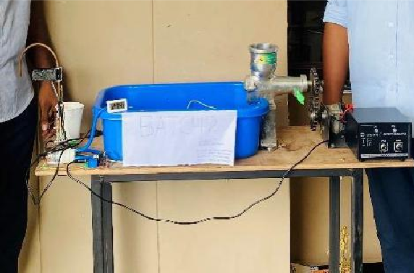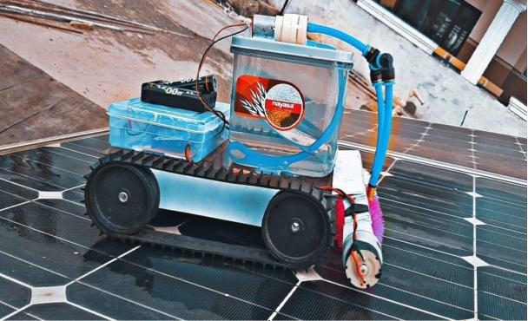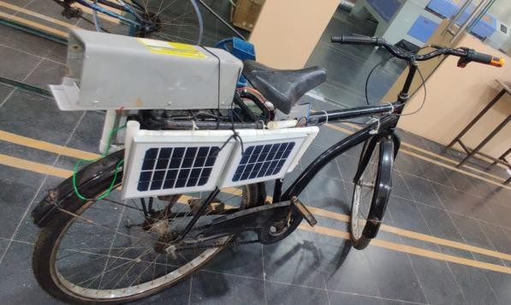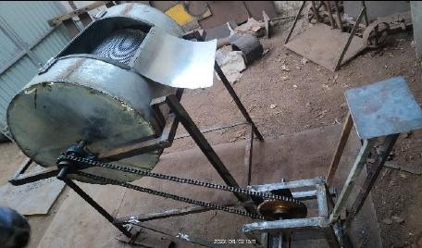

**Highlight selected start-ups established by students/ faculties with mention of founder/Cofounder.**

**Pedal operated washing machine**

**Solar energy operated e-bicycle**

**Solar Panel Cleaning Robot**

**kasaya making machine**

E.

|  |  |  |  |
| --- | --- | --- | --- |
| **Name of the Startup** | **Name and contact details of the founders** | **About startup** | **Kind of support by HI** |

|  |  |  |  |
| --- | --- | --- | --- |
| IllumiSense | Marrapu Likhitha - Founder  Dr.A.Sampath Dakshina Murthy -CoFounder Polarouthu Akash- CoFounder&Technical Engineer  Gompa Sahasra- CoFounder  Dr P.V.Charishma— CoFounder | ILLUMNISENSE is a  revolutionary smart street lighting solution that combines advanced LED technology with hidden surveillance cameras. This innovative system not only illuminates the streets efficiently but also enhances public safety through discreet monitoring. | Funding for Startup |
| Swap Dietetics Private limited | Vikas Panda | 1. Year of establishment: 2019  1. Year of Recognition by Startup/DPIIP: 2019 2. Startup/DPIIP Registration Number: DIPP45863 3. Amount/Funding received from any other organization/VC if any (In Rs): 0(Bootstraped) 4. Name of the organization from which above funding is received if any: NA 5. FDI Investment received if any: NA 6. Year of FDI received if any: NA 7. Company’s turnover (in Lakhs) in the last financial year: 2,23,11,621₹ 8. Startup / DPIIP Certificate copy received (Yes/No): Yes | Funding for Startup |

|  |  |  |  |
| --- | --- | --- | --- |
| Namoona Enterprises Private Limited | Angajala Nikhil Chaitanya[nikhilc.freela](mailto:nikhilc.freelance@gmail.com) [nce@gmail.com](mailto:nikhilc.freelance@gmail.com); mob: 6281460704Angajala Nagalakshmi, [naga23.4lakshmi@gmai](mailto:naga23.4lakshmi@gmail.com) [l.com](mailto:naga23.4lakshmi@gmail.com); mob:  8331904961 | About Startup: Children Toys and Board Games manufacturing company with the brand name “Protoprix" | Concept developm ent and prototype developm ent |

F.

F.



**List if any break through Innovations/Technology Developed at the institute (2-3 Technology with 2-3 lines about technology and**

**Innovation)**

|  |
| --- |
| **3D Printed Bionic Hand** |
| **A boat for removal of water hyacinth from lakes and rivers** |

G.

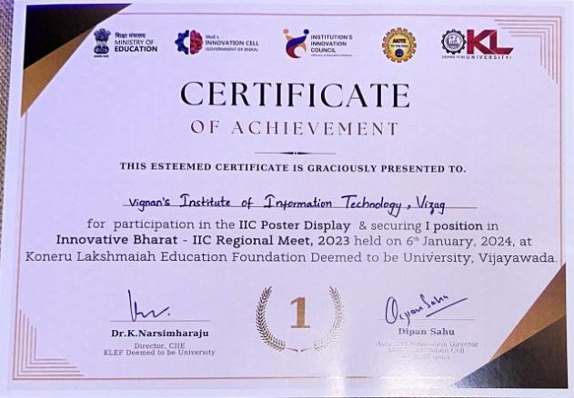

G.



**Participation of IIC-Institute in various programs of central and stage Govt. Highlighting specially for the schemes or programs. NISP Adoption status**

**Trained Faculty:** Yes

**Policy formulation:** Yes

**Policy Implementation:** Yes

**Smart India Hackathon: Yes:210** teams consisting of 6 students each

**Details of social media & Connections of IIC Institute.**

H.

|  |  |  |
| --- | --- | --- |
| **S No** | **Social media** | **Connection ID** |
| 1 | Face book | [https://www.facebook.com/profile.php?id=10](http://www.facebook.com/profile.php?id=10) 0094165417777 |
| 2 | Twitter | <https://twitter.com/vignaniit> |
| 3 | Instagram | [https://www.instagram.com/vignan_viit_vizag](http://www.instagram.com/vignan_viit_vizag)  ?igsh=YW85bWJydDJuODd5&utm_source=qr |
| 4 | YouTube | [https://www.youtube.com/@VignanVizagStud](https://www.youtube.com/%40VignanVizagStudio) [io](https://www.youtube.com/%40VignanVizagStudio) |
| 5 | LinkedIn | [https://www.linkedin.com/in/vignan-](http://www.linkedin.com/in/vignan-) duvvada-254673294/ |

I.

J.



**Contact.**

**Dr. Vallabhaneni Madhusudhan Rao.**

Rector,

Vignan’s Institute of Information Technology (A), Beside VSEZ, Duvvada,

Visakhapatnam-530046.

Email: [budidampad1959@gmai.com](mailto:budidampad1959@gmai.com) Mobile:9440824496.

